KAMPALA QUALITY PRIMARY SCHOOL

INTERNAL END OF YEAR EXAMINATIONS 2019

P.2 READING

**Time allowed 1hr 45min**

Name __________________________________________Stream ____________

**Write the words and sentences correctly.**

1. easts ______________________ 2. oneph __________________

3. ingths ______________________ 4. oombr __________________

5. oryst ______________________

6. hut We live in a ___________________________________________________

7. fun Reading is ____________________________________________________

**Get a small word from a big one.**

8. bookshelf ________________ 9. tea pot ______________

**Underline the oddman out.**

10. chair, table, desk, dress

11. blue, black, yellow, dog

12. Ritah, Ronald, Betty, Mary

**Read and draw**

|  |  |  |
| --- | --- | --- |
| **13. My aunt is washing clothes** | **14. A hen has laid eggs.** | **15. Kato is kicking a ball.** |
|  |  |  |

**Form words using these sounds.**

16. tion ______________________ 17. st _______________________

18. oy _______________________ 19. nd ______________________

**Choose the correct word form brackets to fill the gaps.**

20. The boy is too _________________ to play football. (weak, week)

21. When you __________________ with a knife, it will cut you. (play, pray)

22. We get eggs from _________________ we keep at home. (buds, birds)

23. I will _________________him in the evening. (meet, meat)

**Underline the word with a given sound.**

24. **nk:** sink, pick, slick, rack

25. **ss:** dress, part, cement, cent

26. **tr:** tar, train, tent, tea

27. **nd:** said, sand, bad, prayed

**Replace the last letter with another letter to form a new word.**

28. fool _______________________ 29. mad ________________________

30. meal _______________________ 31. cup _________________________

**Make sentences.**

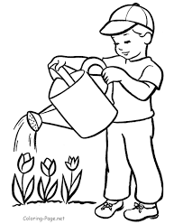

32. _______________________________________________________

[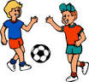](http://www.google.com/imgres?imgurl=http://www.yorkplayspace.org.uk/images/playing_football.gif&imgrefurl=http://www.yorkplayspace.org.uk/whatwedo.php&usg=__X9uN5zfqyZYERdu3Dqjav8XhpvE=&h=185&w=200&sz=10&hl=en&start=23&zoom=1&tbnid=QMD6mOEwc_IpmM:&tbnh=96&tbnw=104&ei=-xO3UefvMsGShgfPi4CgDQ&prev=/search?q=people+playing+football&start=20&sa=N&hl=en&sout=1&biw=985&bih=443&site=imghp&tbs=itp:clipart&tbm=isch&itbs=1&sa=X&ved=0CDIQrQMwAjgU)

33. ______________________________________________________

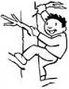

34. _______________________________________________________

[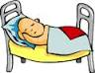](https://www.google.com/url?q=http://www.knowabouthealth.com/stop-dental-cavities-before-they-grow/1438/&sa=U&ei=EB05U4n-CMrBtQaD84DYDA&ved=0CDgQ9QEwBDiIBA&usg=AFQjCNHUzsYS-Yhk6DnF9m8fek4B5DV5yg)

35. ______________________________________________________

**Use these letters to form correct words.**

**e f a t m n s u p**

36. __________________ 37. ________________ 38. ______________

39. __________________ 40. _________________

**SECTION B (2mks each)**

41. **Write words using the given sound.**

p r a) ________________

f nt b) ________________

ai c) ________________

sn l d) _________________

ch n e) _________________

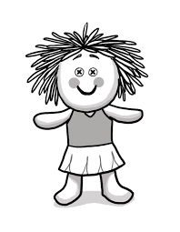42. **Complete the composition correctly.**

Rose’s aunt went to the supermarket and bought a ____________

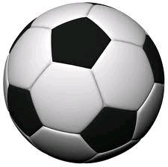

and three _____________ for Rose to play with. When she

[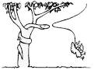](https://www.google.com/url?q=http://www.motherearthnews.com/nature-and-environment/free-mulch-bird-deterrent-country-lore-zmaz79jazraw.aspx&sa=U&ei=DdIOU6mbCs6HyAOFrIHYCQ&ved=0CEYQ9QEwCw&usg=AFQjCNFhk8jOA9Wt450IqHJRFe0PdBy0Ig)

was playing, a snake came from the _______________ and

[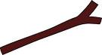](https://www.google.com/url?q=http://www.clker.com/clipart-67650.html&sa=U&ei=jjk5U-LpGsTZsgbUv4CoAg&ved=0CDgQ9QEwBA&usg=AFQjCNGO31JA2ceCpDFLa45nM_huq7kcew)

bit her. Rose got a _______________ and beat the snake

then she ran to the ___________________.

43. **Underline the syllable form the given words.**

a) table b) flower c) basket

44. **Read the story and answer questions about it in full sentences.**

**MERCY GOES TO THE MARKET**

Mercy went to the market to buy some potatoes. At the market, she had a man calling potatoes “Lumonde”. Mercy stopped and taught the man how to say potatoes. The man said “pota” instead of potatoes. Mercy hit the man with a potato and the man said the word correctly. He then gave Mercy the potatoes and she went home happily.

**Questions**

a) Who went to the market?

_________________________________________________________________

b) Why did Mercy go to the market?

_________________________________________________________________

c) Write the title for the story.

_________________________________________________________________

d) What did the man give Mercy?

_________________________________________________________________

e) Did the man learn the word potatoes?

_________________________________________________________________

45. **Write the colours of these things.**

a) sun _________________________ b) charcoal ________________

46. **Use “yes” or “no” to fill the gaps.**

a) Children use the legs to write in the books. ___________________

b) Teachers teach pupils. ______________________________________

c) Most christians go to church on Sunday. ______________________

d) We use the nose for walking. ________________________________

e) Fire is used for washing clothes. ______________________________

47. **Arrange the sentences to form a good story.**

a) One day, Sarah wanted to cook food.

b) She lit the charcoal stove.

c) Peeled and put it in the sauce pan.

d) She went to the market and bought it.

e) Then put the food on fire.

**Good story**

__________________________________________________________________

__________________________________________________________________

__________________________________________________________________

__________________________________________________________________

__________________________________________________________________

__________________________________________________________________

***Merry X-Mas and Happy New Year 2020***